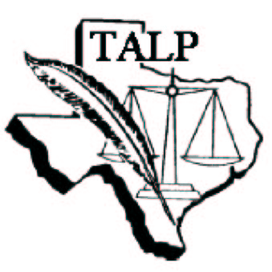
Sponsored by
Texas Association of Legal Professionals
Affiliated with NALS . . . the association for legal professionals

Texas CLE Saturday
Webinar
for Paralegals, Legal Assistants, Legal Secretaries, and Other Lawyers’ Assistants
CLE Credit: 4.0 hours (includes 1.0 hour of ethics)
Meets All Criteria for Recertification CLE for NALS

Registration fee: $25 Members ($30 non-members/$15 students)

March 24, 2018 8 a.m. to 12 p.m.
Location: ScottHulse, PC, 201 E. Main St., El Paso, TX 79901

7:30 Registration and Welcome

8:00 Sexual Harassment Policies: Practical Implications
of the #metoo movement
►Patsy Lopez, Esq.—County Attorney’s Office

9:00 Statutory Fraud in a Real Estate Transaction
►Steven James, Esq.—The Law Office of
Steven James

10:00 Texas Auto Collisions- What is the Fight Really About?
►Daisy Chaparro, Esq.—Flores, Tawney & Acosta

11:00 Ethics and the Legal Professional: Providing Ethical Support
►Judge Maria Salas-Mendoza—120th District Court

Texas alp reserves the right to change or cancel any seminar it deems necessary
For more information, contact:
Rachel Scott (915)219-9351 rachel@expressrecords.net

REGISTRATION FORM

Return registration form/payment to:
Rachel Scott, 5862 Cromo Dr. Suite 205, El Paso, TX 79912; please email a copy of form to:
rachel@expressrecords.net. Deadline to register is March 9, 2018.
Please register me for the March 24, 2018 seminar. Enclosed is a check for $_____________ made payable to (EPALP)
Name:
Employer:
Mailing Address:
Daytime Phone: ____________________________________ E-mail:

